Is AJAX still relevant today?

Short answer: yes, AJAX is alive.
AJAX is far from being dead. In fact, it still runs many top websites today. Every Single-Page-Application (known as SPAs) that you use, or every page that you visit that has a partial page load still uses AJAX techniques today.
If you search for "AJAX" you'll mostly find 1-3-year-old articles that use outdated APIs and libraries.
That is why I put this course together - to keep you updated on the latest AJAX techniques.
Just remember, AJAX is not a programming language. It really is a technique that you use (via JavaScript) that allows a browser to send/receive data to/from a server.
However, how you write AJAX may change based on what libraries or frameworks you are using in your project.
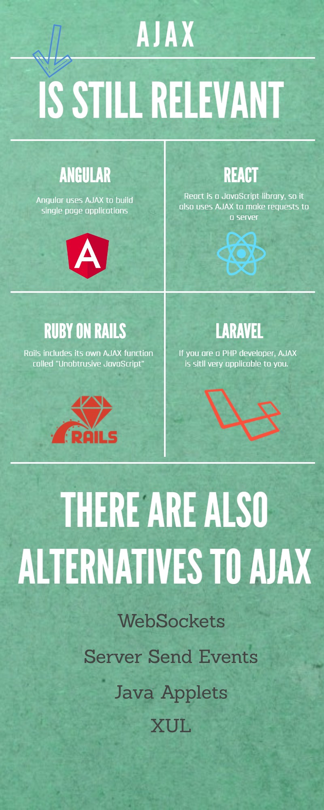
So, there you have it.
AJAX is still awesome and very much relevant.
See you in the next lecture.

